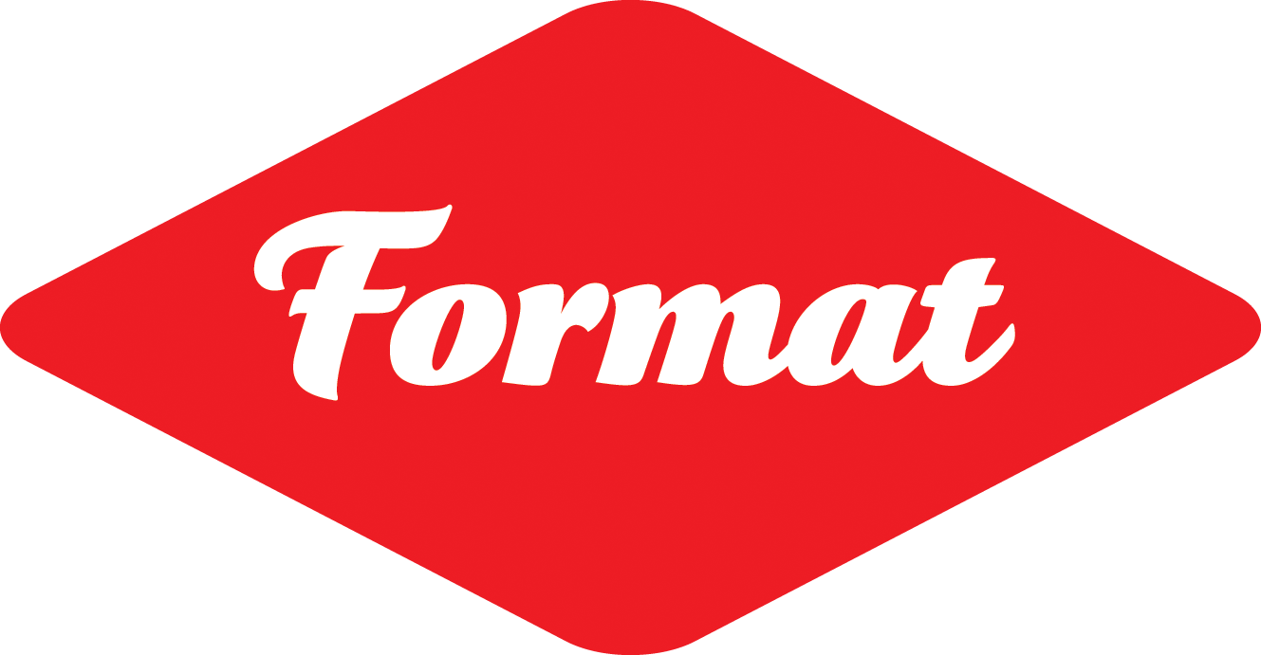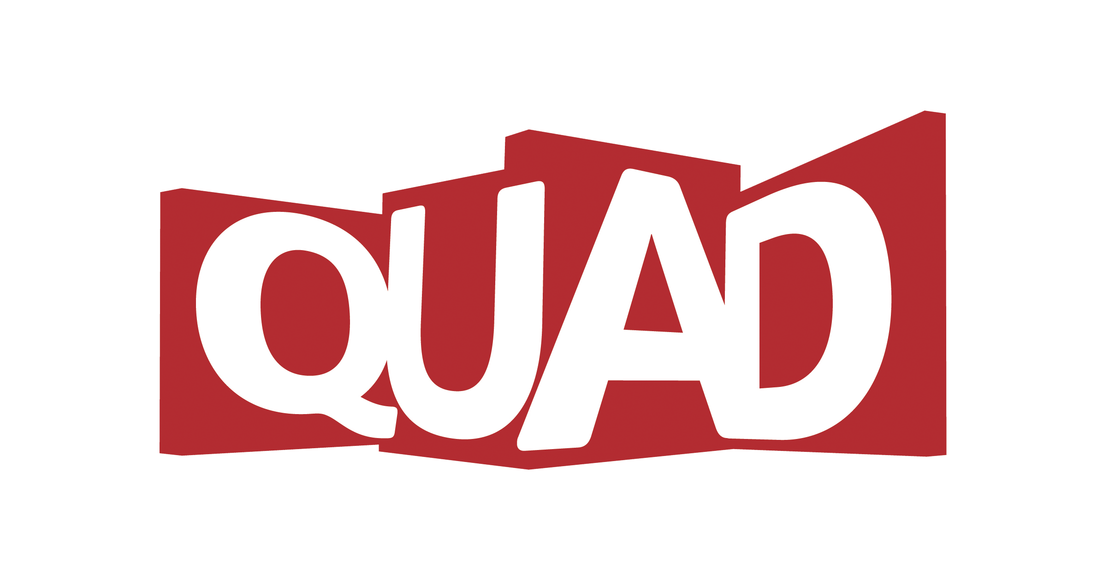

FORMAT23 Volunteer Application Form FV12102022
Thank you for considering volunteering for FORMAT International Photography Festival 2023.

This form is designed to help you think about the volunteer role you are interested in undertaking within the FORMAT23 team.

FORMAT International Photography Festival is one of the UK’s largest and most prestigious photography festivals.

FORMAT23 will launch on the 16 March 2023 and run until 09 April 2023.
2023 will see FORMAT return to Derby after going online due to the COVID19 pandemic and we want to make it an open and welcoming celebration of photography to all visitors! This year’s festival will include an ambitious programme of exhibitions drawn from FORMAT’s first ever OPEN theme open call; events; in person and online talks; portfolio reviews and conference - working with over 200 international photographers, curators and industry professionals.

FORMAT’s success relies on the enthusiasm and hard work of a small group of staff and committed volunteers and has always been a triumph thanks to volunteer dedication.

FORMAT offers volunteers the invaluable experience of working with internationally renowned curators, photographers and festival management team, and the camaraderie of being part of an international arts experience.

FORMAT23 will provide training, support and (for regular volunteers) a reference to help with your future career amongst other benefits. Previous volunteers, who have excelled in their roles by showing passion and dedication have gone on to be employed by QUAD, FORMAT, and many other creative organisations worldwide.

We will make every effort to offer a range of experiences and to match individuals where possible to particular areas of interest. We are interested in volunteers from all backgrounds and from areas of the community. There is no previous experience necessary!

What we can offer you:
- A sociable experience to meet other volunteers and like-minded people
- A professional reference that can help you when applying for jobs in the industry (when committing to a minimum of 3 sessions)
- A photography workshop with a regional artist
- Travel expenses of £3/day (for volunteers travelling over 3 miles*)
- 10% Discount in the QUAD café
- Career development talks from the FORMAT/QUAD team
- Opportunities for portfolio reviews with FORMAT/QUAD Curatorial team
- Opportunities for 1-to-1 development session with the FORMAT Volunteer coordinator
- Marketing experience opportunities on the FORMAT Volunteers Instagram
- After festival party!
(*If travel limitations would be a barrier to you being able to volunteer, please do get in touch at the email address below.)

If you are interested in taking part, please complete the following form and return it to formatvolunteers@derbyquad.co.uk, or you can return it by post to: FORMAT Volunteer Coordinator, QUAD, Market Place, Cathedral Quarter, Derby. DE1 3AS.

Deadline for applications: Sunday 27 November 2022 23:59 GMT

Hello! Please tell us about yourself and why you’d like to volunteer for FORMAT23.
Name
Preferred Pronouns | She/Her He/Him They/Them Other(Describe)…..............
Contact Phone Number
Email
Address
Postcode |  | Country
I am aged over 18 | YES / NO (please delete)

Are there particular types of volunteer work which you are interested in?
(Please indicate all that apply)

- General FORMAT volunteer, supporting a range of areas
- Exhibition Installation and/or Exhibition Take Down support
- Festival Marketing
- Invigilation of Exhibitions & Staffing of FORMAT23 Information Desk
- Marshalling and providing members of the public with information
- Portfolio Review support
- Conference Support
- Guest Hospitality
- Events / Talks / Exhibition Tours / Workshop support
- Other (please specify)
__________________________________________________________

Which area(s) from the previous list interests you most? Please tell us why. (Max 100 words)

What are your strengths, or what do you feel you can contribute to the volunteer team?
Please list any of your skills or any previous relevant experiences that you feel are appropriate to your application, e.g. wood working skills, worked in hospitality, digital or social media experience, etc.
(Max 100 words)

Please use this space if you would like to tell us anything else about yourself, why you want to be part of FORMAT23, or about your interests so that we can get to know you!
(Max 100 words)

Availability
To help us plan ahead, it is useful for us to know about your availability and how much time you can give to volunteering for FORMAT23. We can work around your availability, so please let us know below when you'll be available and we’ll do our best to accommodate you’re requests. Even if you can only help out once or twice, this really helps us make the festival possible!
Please let us know about your availability (tick all that apply)*:

- Exhibition Installation: Early February 2023 – 13th March 2023 (subject to change)
- Event and Launch preparation: 7th March 2023 – 16th March 2023
- FORMAT23 Launch night: Thursday 16th March 2023
- FORMAT23 Launch Weekend: Friday17th March – Sunday 19th March 2023
- FORMAT23 Festival period (including Portfolio Reviews and events, tours and talks): 16th March 2023 – 09th April 2023
- Exhibition Takedown: For 2 weeks following the exhibition closures (TBC 10th -23rd April 2023)

*(We know that things can change - this is just an indicator of your availability).

Approximately what amount of time would you be able to volunteer for?
(eg. How many days or hours per week, or how many days in total could you volunteer for approx.)?

At what times do you prefer to volunteer? (Tick those that apply)
¨ Flexible ¨ Mornings ¨ Afternoons ¨ Evenings

And do you prefer (Tick those that apply):
¨ Half days (10:00-14:00/14:00-18:00) ¨ Full days ¨ I don’t mind

Is there anything NOT listed in ‘What we can offer’ that you feel would incentivise you to volunteer? Please describe below (Max 100 words)

Do you currently have an in-date DBS certificate? (Not essential)

Yes No

Interviews
Informal interviews will be scheduled to take place from early December 2022 to late February 2023.
Successful applicants will hear from us on an ongoing basis, and by 5 March 2023.
If you require any reasonable adjustments to the interview process to make it as accessible as possible, please describe below:

Training
Training will be provided prior to the launch of the festival in Derby. This will be organised by the FORMAT Volunteer Coordinator and communicated upon confirmation of your participation.
Please note that all personal details will be treated with confidentiality.

To apply:
Please complete this form and email to formatvolunteers@derbyquad.co.uk
Alternatively, you can post the forms to:
FORMAT Volunteer Coordinator, QUAD, Market Place, Cathedral Quarter, Derby DE1 3AS.
Or you can hand your completed form in at QUAD Box Office, addressed to the FORMAT Volunteer Coordinator.

Please note: To support FORMAT Festival as a volunteer, you will be required to provide proof of your right to work in the UK, this can be in the form of a Photo Passport or a Birth Certificate AND proof of National Insurance number (P60, HMRC Letter, NI Card etc).

Equal Opportunities
We would be very grateful if you would complete our anonymous equal opportunities survey to help us report on and improve our recruitment processes. Please download a copy and return the completed form with your application – any information will not affect your application and information will be stored anonymously.

All applicants’ information is held in line with QUAD’s privacy policy adhering to GDPR, for more information about this please visit: https://www.derbyquad.co.uk/privacy-policy
Thank you for your time we look forward to hearing from you!

