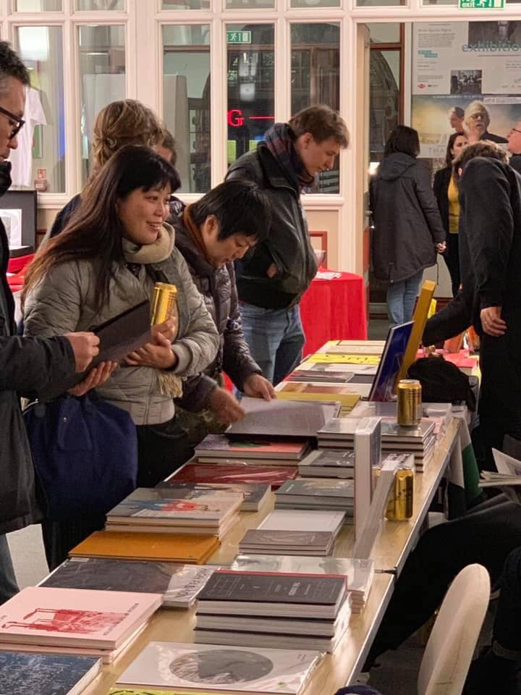

FORMAT23 Photo Market
16 – 19 March 2023
Derby, UK

FORMAT International Photography Festival is one of the UK's leading non-profit international contemporary festivals of photography and related media. The biennale programme celebrates the wealth of contemporary practice in international photography. FORMAT is the place to see an incredible range of new work alongside some of the best-known practitioners and new discoveries in the world. FORMAT23 will run between 16 March and 9 April 2023 in Derby, UK.

This information pack is for publishers to register their interest in taking part in the FORMAT23 Photobook market. The FORMAT Photobook Market will take place from Friday 16 – Sunday 19 March 2023 as one of the feature events taking place across the city during our opening weekend, and we’d love to welcome new and exciting publishers to be involved.

The FORMAT23 Photobook Market & Exhibition will take place in a prime location in the city center, close to our headquarters at QUAD. As well hosting the Photo Market, the venue will be hosting an exhibition of international artists and a launch party on the Thursday evening before the public opening. Our Photo Market will be an eclectic and vibrant place, with book publishers, rare book traders, photo magazines, independent photobook producers, equipment dealers and everything in-between.

The FORMAT Photo Market will provide a unique opportunity for face-to-face networking; to communicate and sell to professional photographers and the general public alike. This unique environment will enable it to be a market like no other; where cutting edge creativity will emphasise the best of what photography is and can be.

FORMAT Photo Market is one of the biggest events taking place on the opening weekend of the festival and will consequently feature heavily in our print and online marketing campaigns. Additionally, all participants will be invited to join us for our VIP launch events and after parties running throughout the launch weekend.

Applicant Information
Exhibitor Name:
Organisation Name:
Address:
City: |  | Postal/ZIP Code:
Country:
Phone: |  | Email
Website/Social Media

Product Information
Please specify what products and/or activities you wish to bring to the FORMAT Photo Market. Mark with an X. Please provide information about any events and activities you wish to hold at the Photo Market in the ‘Further Information’ section provided below.
 | Photobooks & Zines |  | Rare or Specialist Books |  | Photographic Ephemera
 | Magazines |  | Equipment |  | Prints
Other (please state)

Table Hire
Due to the nature of this event and availability, we are offering interested parties table hire, rather than specific stalls and locations. As we get closer to the event we will work to allocate the available spaces for all applicants.
Participants will need to be present to setup and prepare stalls on Thursday 16 March 2023.
Costs - One table is priced at £75.00 for the entire weekend (incl. two chairs). All prices inclusive of VAT. Payments will be processed after we have received your booking.
Measurements - Tables measure at 6 ft x 2 ft 6 inch

Further Information
Please provide further information about any events or activities you wish to hold at the FORMAT Photobook Market below.

Applications
Deadline for Applications: Friday 30 December 2023, 11:59pm GMT
FORMAT will conduct a selection from all applications. Successful applicants will be contacted by mid January 2023
For further information or queries please contact formatphotobook@derbyquad.co.uk
Applications should be submitted as PDF’s via email to formatphotobook@derbyquad.co.uk with ‘FORMAT Photobook Market Publishers’ in the subject line

www.formatfestival.com
www.derbyquad.co.uk

