FORMAT21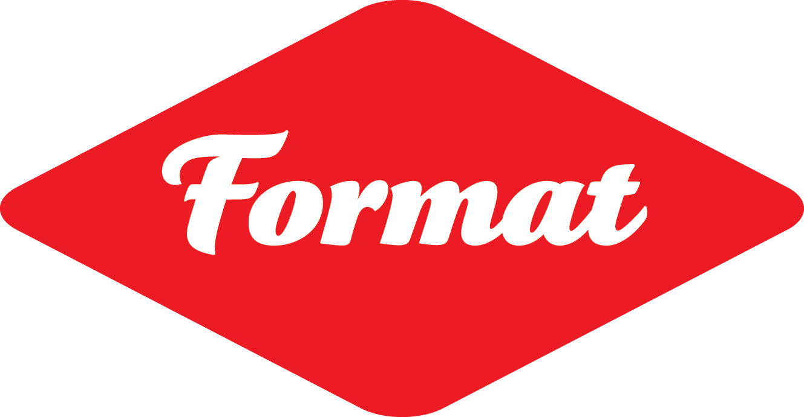 Volunteer Application Form FV02122020

Thank you for considering volunteering for FORMAT International Photography Festival 2021.

This form is designed to help you think about the volunteer role you are interested in undertaking within the FORMAT21 team.

FORMAT International Photography Festival is one of the UK’s largest and most prestigious photography festivals.

FORMAT21 will launch on the 11th March 2021 and run from 12th March 2021 until 11th April 2021 (11th TBC).
In these unprecedented circumstances, this year’s festival will include an ambitious programme of both online and real world exhibitions, events, talks and portfolio reviews, working with over 300 international photographers, curators and industry professionals

Due to the ongoing Covid-19 situation, some details for FORMAT21 are subject to change, but all real world events will be run in line with current government guidelines, and all venues will be COVID secure, with appropriate PPE, Health and Safety, and audience monitoring and management systems in place to ensure a safe working environment for everyone.

FORMAT’s success relies on the enthusiasm and hard work of a group of staff and committed volunteers.

FORMAT offers volunteers the invaluable experience of working with internationally renowned curators, photographers and festival management team, and the camaraderie of being part of an international arts experience. This year FORMAT21 will be looking for both real world volunteer support, and online volunteer support.

FORMAT21 will provide training, support and (for regular volunteers) a reference to help with your future career. Previous volunteers, who have excelled in their roles by showing passion and dedication have gone on to be employed by QUAD, FORMAT, and many other creative organisations worldwide.

We will make every effort to offer a range of experiences and to match individuals where possible to particular areas of interest. We are interested in volunteers from all backgrounds and from areas of the community. There is no previous experience necessary!

The festival will be offering volunteers a range of incentives. Unfortunately, due to the number of volunteers we work with, we are not able to reimburse you for personal food or travel expenses during the festival. If this would be a barrier to you volunteering, please get in touch.

If you are interested in taking part, please complete the following form and return it to formatvolunteers@derbyquad.co.uk, or you can return it by post to: FORMAT Volunteer Coordinator, QUAD, Market Place, Cathedral Quarter, Derby. DE1 3AS. (Please note, if QUAD is required to close, responses to paper applications may be delayed.)

Deadline for applications: Sunday 31st January 2021
Hello! Please tell us about yourself and why you’d like to volunteer for FORMAT21.
Name
Contact Phone Number
Email
Address
Postcode
I am aged over 18 | Yes / No

Are you able / interested in being an online volunteer or a real world volunteer or both?
- Online only
- Real World only
- I’m happy to do either

Are there particular types of volunteer work which you are interested in?
(Please indicate all that apply)

- General FORMAT volunteer, supporting a range of areas (online and/or real world)
- Mass Isolation FORMAT support: Proof reading text online, uploading text & images etc. (online)
- Marketing support (online)
- Marketing support (real world)
- Virtual Exhibition support: uploading images, annotation, leading virtual tours etc. (online only)
- Exhibition Installation and/or Exhibition Take Down support (real world only)
- Invigilation of Exhibitions & Staffing of FORMAT21 Information Desk (real world only)
- Marshalling and providing members of the public with information (real world only)
- Portfolio Review support (online only)
- Guest Hospitality (online and/or real world)
- Events / Talks / Workshop support (online)
- Events / Talks / Exhibition Tours / Workshop support (real world)
- Other (please specify) __________________________________________________________

Which area(s) from the previous list interests you most? Please tell us why. (Max 100 words)

What are your strengths, or what do you feel you can contribute to the volunteer team?
Please list any of your skills or any previous relevant experiences that you feel are appropriate to your application, e.g. wood working skills, worked in hospitality, digital or social media experience, etc.
(Max 100 words)

Please use this space if you would like to tell us anything else about yourself, why you want to be part of FORMAT21, or about your interests.
(Max 100 words)

Availability

So we can plan ahead, it is useful for us to know about your availability and how much time you can potentially volunteer for FORMAT21 for. We can work around your availability, so please let us know below when you'll be available and we’ll do our best to accommodate.

Please let us know about your availability (tick all that apply)*:

- Mass Isolation FORMAT preparation: January 2021– March 2021
- Online Exhibition and Events preparation: Early January 2021 – Early March 2021
- FORMAT21 Marketing (online and real world): Early February 2021 – Mid March 2021
- Exhibition Installation: Early February 2021 – 13th March 2021
- Real world Venue, Event and Launch preparation: 1st March 2021 – 10th March 2021
- FORMAT21 Launch night: Thursday 11th March 2021
- FORMAT21 Festival period (including Portfolio Reviews and most online and real world events, tours and talks): 12th March 2021 – Mid April 2021 (TBC 11th)
- Exhibition Takedown: For 2 weeks following the exhibition closures (TBC 12th -23rd April 2021)

*(We know that things can change - this is just an indicator of your availability).

Approximately what amount of time would you be able to volunteer for? (eg. How many days/hours per week, or how many days in total)?

At what times do you prefer to volunteer?

Flexible Prefer mornings Prefer afternoons Prefer evenings

And do you: Prefer half days Prefer full days I don’t mind

Equal Opportunities

We would be very grateful if you would complete our anonymous equal opportunities survey to help us report on and improve our recruitment processes. Just follow or copy and paste this link into your web browser:

https://www.surveymonkey.co.uk/r/quadhr

I have completed the online equal opportunities survey: Yes No

Interviews

Successful applicants will hear from us on an ongoing basis, and by 12th February 2021.

Informal interviews will be scheduled to take place from mid December 2020 to late February 2021.

Training

Training will be provided prior to the launch of the festival in Derby. This will be organised by the FORMAT Volunteer Coordinator and communicated upon confirmation of your participation.

Please note that all personal details will be treated with confidentiality.

To apply
Please complete this form and email to formatvolunteers@derbyquad.co.uk

Alternatively, you can post the forms to:
FORMAT Volunteer Coordinator, QUAD, Market Place, Cathedral Quarter, Derby DE1 3AS.
Or you can hand your completed form in at QUAD Box Office, addressed to the FORMAT Volunteer Coordinator.
(Please note that in the event that QUAD is required to close, responses to paper applications may be delayed).

Thank you for your time.

